

RPP User Manual

- Create Action Plan for Current Mutual Fund –Lumpsum

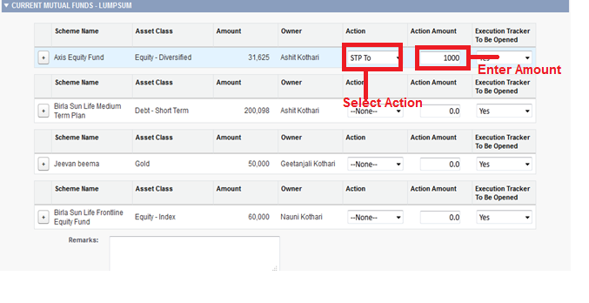

- Create Action Plan for Current Mutual Fund – Running SIP
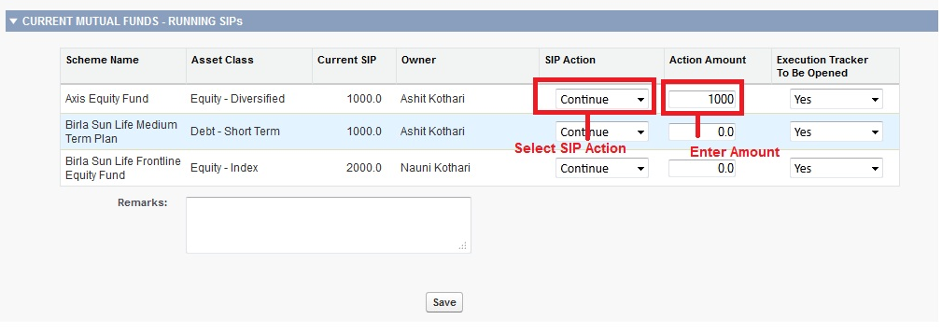

- Create Action Plan for Goal Asset.

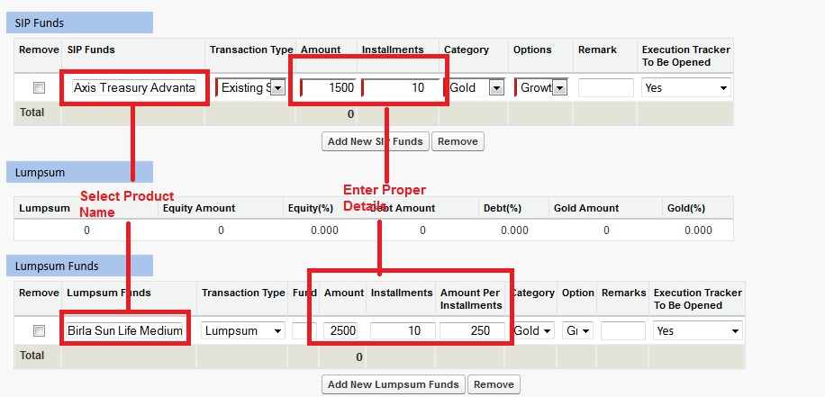

- Create Action Plan for Life Insurance
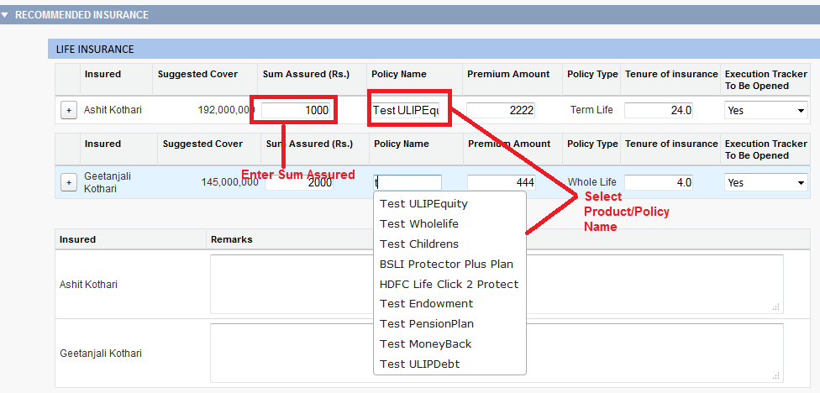
- Create Action plan for General Insurance
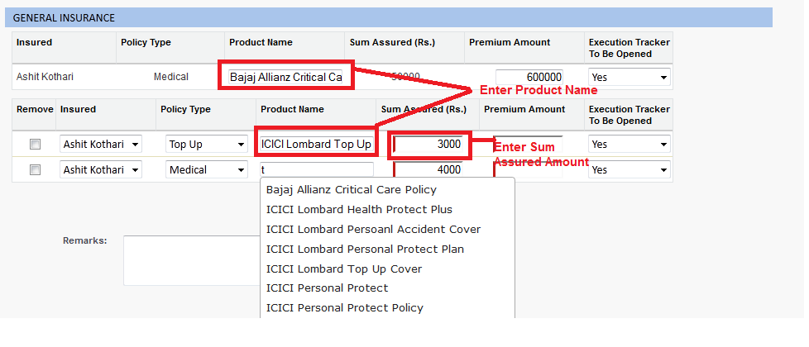
- Save the Action plan and RPP Created for given Action Plan.
- In Remark Section, User will get detail message about respective Product. The message will be display whenever your Product or Commission is not available.
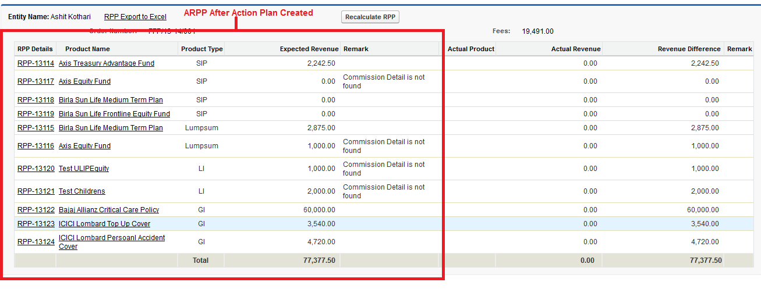
- Now, Execution Tracker will be created for Action plan.
- Go to Running SIP and Lumpsum Funds.
- Enter Required Data and Assign to Ops for further process.

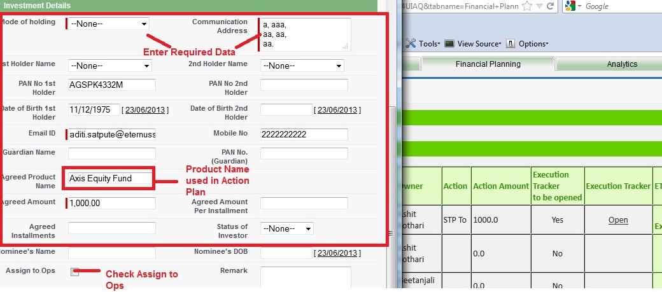

- Note: The above process is same for all Goal Asset, Life Insurance and General Insurance.

- It may possible that User can change the Product Name in Execution Tracker which is not similar to Action Plan Product Name.
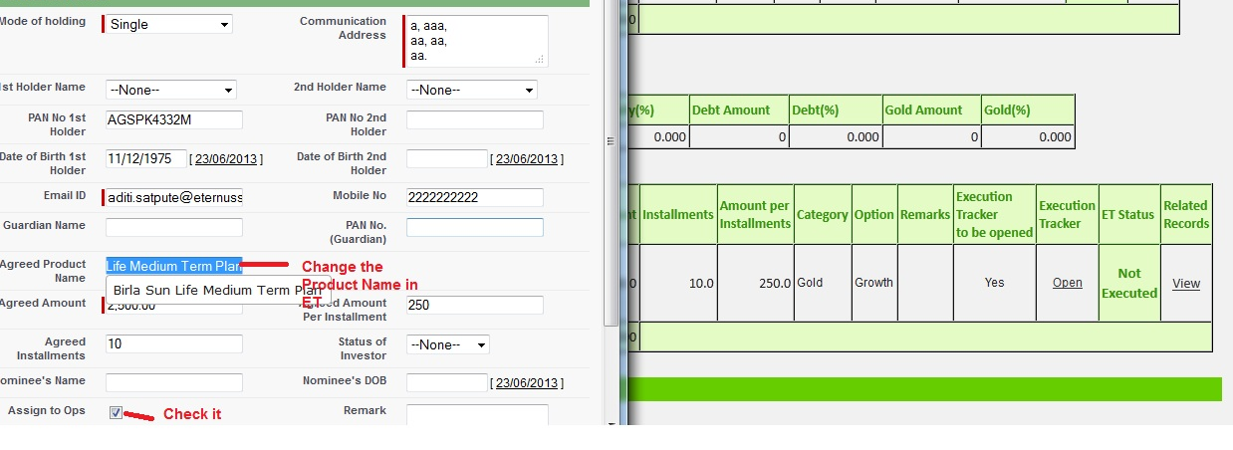

- User changed the Product Name in Execution Tracker and Assign it to Ops for further processing.
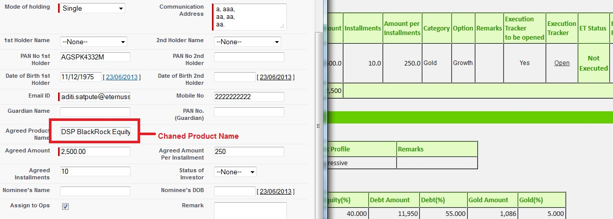

- After Saving Execution Tracker , RPP will be Created for given Execution Tracker
- Below is snapshot where you will compare Your Actual product Name (Execution Tracker) with Recommended Product Name (Action plan).
- In Remark Section, User will get detail message about respected Product. The message will be display whenever Actual Product or Commission is not available.

